SHARE IN OUR LEARNING: Year 5 Autumn 2
English  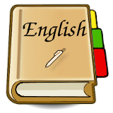 | Poetry (cinquains, poems with figurative language)  - Learn poems off by heart  - Prepare poems to read aloud and perform  - Explore the meaning of figurative language  - Comment on writer’s choice of language for effect  - Selecting appropriate vocabulary  - Use a thesaurus  Biographies and autobiographies  - Summarise the main ideas drawn from a text  - Use text marking to identify key information in a text  - Make notes from text marking  - Using brackets, dashes or commas to indicate parenthesis  - Using a wide range of devices to build cohesion within and across paragraphs  - Devices to build cohesion, including adverbials of time, place and number
Mathematics  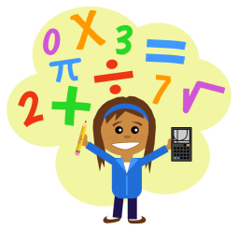 | - Angles  - Length, Perimeter and Area  - Fractions  - Decimals  - Geometry  - Reading timetables
Science | Plant Reproduction  • Describe the life process of reproduction in some plants  Properties of materials  - To compare and group together everyday materials on the basis of their properties, including their hardness, solubility, transparency, conductivity (electrical and thermal), and response to magnets  - To give reasons, based on evidence from comparative and fair tests, for the particular uses of everyday materials, including metals, wood and plastic
Topic | Marvellous Maps (Geography)  - Name and locate counties and cities of the United Kingdom,  - Use 8 points of a compass, six-fig. grid references, symbols and key (including use of Ordnance Survey maps) to build their knowledge of the UK  - Use fieldwork to observe, measure, record and present the human and physical features in the local area using a range of methods, including sketch maps, plans and graphs, and digital technologies.  Santa’s Little Helpers (DT)  - Design, make and evaluate a Christmas toy, using pneumatics.
PE  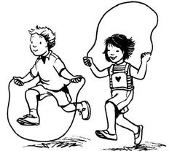 | REAL PE  Handball –  - Show growing awareness of space in team games  - Work to keep or gain possession  - Apply a broad range of skills to different situations
Other  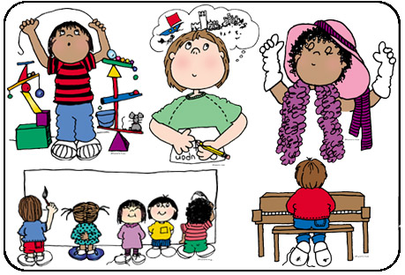 | Computing - Using algorithms (CS) Use coding methods to control sprites. Make sequential instructions.  PSHE – Anti-bullying Week, resilience  Music – Guitars  RE – Christianity - Where can people find guidance on how to lead their lives?  Art – Painting

