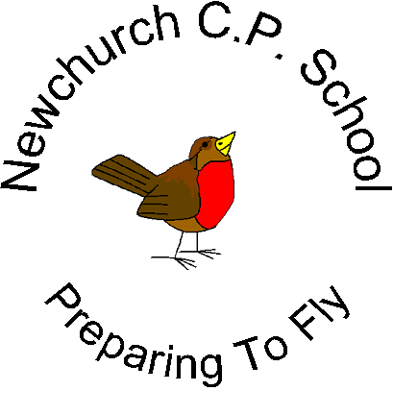
Newchurch Community Primary School
Glebeland
Culcheth
Warrington
WA3 4DX
01925763427

Dear Parents and Carers
ARE YOU ENTITLED TO CLAIM A £50 ‘EDUCATION VOUCHER’ TO SUPPORT YOUR CHILD’S EDUCATION AT NEWCHURCH PRIMARY?

Did you know that just registering your child for Free School Meals means that the school gets extra money to support your child?

The Government is giving money to schools to help children from lower income families do their very best. The funding is called ‘Pupil Premium’ and is used to provide a variety of resources and support for those pupils.

If you are registered for Free School Meals you could use your £50 Education Voucher towards the cost of things like uniform, educational trips or school photographs.

How does it work?
- First, check if you qualify for Free School Meals- it is not just if you are unemployed, so please look at the list overleaf.
- Registering is really quick and easy – if you think you qualify but need more information, contact Mrs Heath or Mrs Burrows in the office or Free School Meals team at Warrington Borough Council on 01925 443170.
- If you want your child to have a free, healthy meal at lunchtime, that’s great -they will get the free meal (saving nearly £400 a year), the £50 voucher and the school gets additional funding to support your child’s education.
- If you don’t want your child to have the school meal they can continue as normal – as long as you qualify and are registered, the school still gets the additional funding.
- Even if your child is already getting a free meal under the ‘free meals for infant children’ please still register to get your £50 voucher.

No one will know you have registered and it will not affect any other benefits you are claiming. Some parents pay for dinners by Direct Debit and so children entitled to Free School Meals are not identifiable.

If you have any queries relating to this please call the school office on 01925763427.

Yours sincerely

Mrs S Lawrenson
Headteacher

Do you qualify for Free School Meals?
You can register your child for Free School Meals if you get any of these benefits:

- Income Support (IS)
- Income-based Jobseekers Allowance (IBJSA)
- Income based & contribution based job seekers allowance or employment support allowance on an equal basis
- Income related employment and support allowance (IRESA)
- Support from NASS (National Asylum Support Service) under part 6 of the Immigration and Asylum Act 1999
- The guarantee element of the State Pension Credit
- Child Tax Credit (with no Working Tax Credit) with an annual income which does not exceed £16,190 OR
- Working tax “run on” – the payment someone may receive for a further four weeks after they stop qualifying for working tax credit.
- Working tax “run on” – the payment someone may receive for a further four weeks after they stop qualifying for working tax credit.
- Universal Credit

Frequently Asked Questions
How do I register for Free School Meals?
Just fill in this box below, return to school and we will ask the Free School Meals team at WBC to check if you are entitled. If you are, we will contact you about your voucher.

 | Parent/Guardian 1 |  |  |  |  |  |  |  |  | Parent/Guardian 2
Surname
First name
Date of birth
National Insurance number

How much will I receive in vouchers?
£50 is allocated at the beginning of each school year in September.

How long is the voucher valid for?
The voucher is valid for one school year and can be used at any time up to the end of July. As long as Pupil Premium funding continues, we will issue a new voucher each year. Any left over money from the previous year cannot be carried over into the following year.

If I want to use the voucher for uniform how do I do it?
To use for school uniform you need to show your voucher at our uniform supplier, they will record the cost and charge the school.

What else can I use the voucher for?
Residential visits, school trips, books bought at the school book fairs or school photographs.

My child is due to start in September. Can I use the voucher in advance to buy uniform?
We can’t issue vouchers until your child has already started in school but if you keep the receipt, you will be able to claim your money back once they have started school.

SIGN UP NOW TO CHECK IF YOU CAN CLAIM YOUR £50 EDUCATION VOUCHER!

