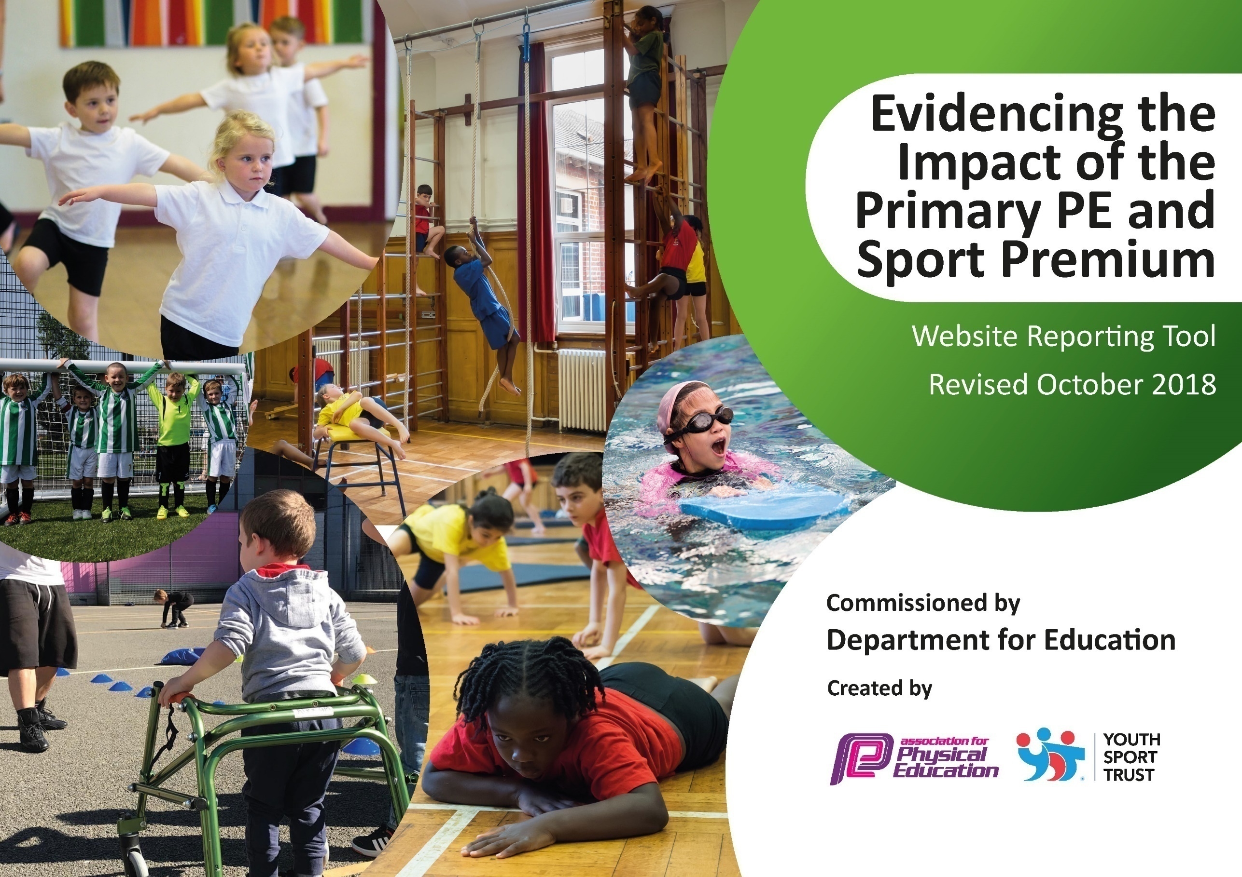

Schools must use the funding to make additional and sustainable improvements to the quality of PE and sport they offer. This means that you should use the Primary PE and Sport Premium to:

- developoraddtothePEandsportactivitiesthatyourschoolalready offers
- buildcapacityandcapabilitywithintheschooltoensurethatimprovementsmadenowwillbenefitpupilsjoiningtheschoolinfuture years

Please visit gov.ukfor the revised DfE guidance including the 5 key indicators across which schools should demonstrate an improvement. This document will help you to review your provision and to report your spend. DfE encourages schools to use this template as an effective way of meeting the reporting requirements of the Primary PE and Sport Premium.

We recommend you start by reflecting on the impact of current provision and reviewing the previous spend.
Under the Ofsted Schools Inspection Framework, inspectors will assess how effectively leaders use
the Primary PE and Sport Premium and measure its impact on outcomes for pupils, and how effectively governorshold them to account
for this.

Schools are required to publish detailsof how they spend this funding as well as on the impact it has on pupils’ PE
and sport participation and attainment.
We recommend regularly updating the table and
publishing it on your website as evidence
of your ongoing review into how you are using the money
to secure maximum, sustainable impact. To see an example of how to complete the table please click HERE.

Support for review and reflection - considering the 5 key indicators from DfE, what development needs are a priority for your setting and your students now and why? Use the space below to reflect on previous spend, identify current need and priorities for the future.

Key achievements to date: | Areas for further improvement and baseline evidence of need:
Autumn Term  PE apprentice appointed and is being supported by teaching staff to develop his understanding of the teaching of PE.  Competitive sports already begun are on target to achieve 100% of KS2 children being given the opportunity to represent school in inter-school sports competitions this academic year..  Numbers of children being active at lunch times is on the rise.  Completed a Race for Life  Spring Term  Increased number of extra-curricular clubs to the greatest number we have ever had. These include two football clubs, Change 4 Life, rugby, multi-sports, ultimate Frisbee, Wake and Shake, and netball  Brought in Commando Joe’s, an external provider to help develop our PE curriculum for outdoor learning  Use of new equipment has continued to engage chn in lunchtime activities  ‘March Madness’ event has given all chn the opportunity to participate in intra-school competitions. Throughout the month, we ran 4 intra-school competitions.  Nine more inter-school events took place in the Spring term which, again, is more than we have ever had.  Summer Term  Three further inter-school events and two more lunch time intra-school competitions  Sports Day  Year 3 and Year 4 swimming lessons. Numbers of children achieving swimming proficiency have increased on previous year. | Autumn Term  Promote awareness of PE around the school with bulletin boards to show everyone what is happening.  Gradually increase the percentage of time our PE apprentice is spending delivering lessons.  Spring Term  Organise intra-school events for the Summer term. Include Y6 chn to help develop sports-leaders.  Develop new ways to show how children have made progress through their PE lessons.  Summer Term  Objectives for next year are to enhance our dance curriculum which, through pupil and staff conferencing, has been identified as an area in which we would like to improve our skills base.  Develop Forest Schools activities to help promote outdoor learning in PE.

Meeting national curriculum requirements for swimming and water safety | Please complete all of the below:
What percentage of your Year 6 pupils could swim competently, confidently and proficiently over a distance of at least 25 metres when they left your primary school at the end of last academic year? | 91%
What percentage of your Year 6 pupils could use a range of strokes effectively [for example, front crawl, backstroke and breaststroke] when they left your primary school at the end of last academic year? | 91%
What percentage of your Year 6 pupils could perform safe self-rescue in different water-based situations when they left your primary school at the end of last academic year? | 100%
Schools can choose to use the Primary PE and Sport Premium to provide additional provision for swimming but this must be for activity over and above the national curriculum requirements. Have you used it in this way? | Yes/No

Action Plan and Budget Tracking
Capture your intended annual spend against the 5 key indicators. Clarify the success criteria and evidence of impact that you intend to measure to evaluate for students today and for the future.

Academic Year: 2018/2019 | Total fund allocated: £17830  Carried over from previous Year:  £3200  Total: £21,030  Total Spent £20,940  Remaining: £90 | Date Updated: June 2019
Key indicator 1: The engagement of all pupils in regular physical activity – Chief Medical Officer guidelines recommend that primary school children undertake at least 30 minutes of physical activity a day in school |  |  |  | Percentage of total allocation:
 |  |  |  | £2100 – 10%
School focus with clarity on intended impact on pupils: | Actions to achieve: | Funding allocated: | Evidence and impact: | Sustainability and suggested next steps:
Bought into the Warrington School Sports Partnership. This allows our children to participate in vast amounts of inter-school competition as well as hire a wide range of specialised sports equipment to give children a greater range of activities to immerse themselves in.  Sports and games equipment purchased for lunchtime club with MDA’s | Ensure regular communication with the WaSSP to keep changing the hired equipment. PE Coordinator to ensure competitions are being booked for children to have opportunities to compete against other schools.  Equipment such as skipping ropes, balls, bats, chalks to be purchased. Work with MDA’s to develop a register system to record children who are/aren’t participating. | £1700  £400 | New and hired equipment from WaSSP is being used regularly at lunchtimes, ensuring that children are more active and engaged in sport. Children have enjoyed the opportunity to use archery sets, skipping ropes, speed stack, rowing machines, badminton and fencing equipment this academic year.  MDA’s report a large increase in physical activity at lunchtimes due to enthusiasm for equipment.  100% of KS2 children have had the opportunity to participate in both inter and intra-school competitions this year.  Children have such a wealth of equipment at their disposal that we have seen great levels of engagement in sports and games at lunchtimes. PE apprentice has been integral in organizing games and intra-school competitions to allow all children to participate. Medals, trophies and certificates were purchased to give a physical reward for participation. | Continue to provide new and engaging sporting opportunities. Generate register system to gather data on numbers of chn.  To increase our contacts with external clubs who can provide children with meaningful, long-lasting links with particular sports of interest. E.g. running clubs, rowing clubs etc.  Continue to monitor the quality of PE equipment. Audit PE equipment, especially perishables such as chalks to ensure that there is always sufficient supply for demand. Look at ways of linking dance into lunchtimes through discos.
Key indicator 2: The profile of PE and sport being raised across the school as a tool for whole school improvement |  |  |  | Percentage of total allocation:
 |  |  |  | 2680 – 13%
School focus with clarity on intended impact on pupils: | Actions to achieve: | Funding allocated: | Evidence and impact: | Sustainability and suggested next steps:
LS to promote and develop PE, sport, wellbeing and healthy lifestyles throughout the school community in TLR role.  Celebrate chn’s sporting successes with a celebrations on the school Twitter page and on the school newsletter.  PE display board to be placed in the outdoor classroom as well as bulletin board to raise awareness of clubs and competitions taking place.  Deployment of Healthy Lifestyle Champions in school who will work with PE lead to help promote participation within the school | To lead on all aspects of the PE curriculum as shown within this document.  To be accountable for the spending of the PE and sport Premium.  Create a certificate for each class.  Ensure system focuses on those chn who are least active to encourage them to want to increase participation.  Make parents and children aware of the board and continue to change to show sporting achievements in the school.  Champions to attend training days with PE lead to develop their skills and confidence. | £2630  £50 | Greater numbers of chn wishing to take part in events. Chn also really keen to show off their achievements from their external clubs such as swimming, dance, gymnastics and golf.  Y6 chn are running the Active Lifestyles club themselves with LS overseeing and providing feedback to them for future sessions.  Champions have been trained by LS to set up and run the C4L club under his supervision. Their enthusiasm for generating new ideas and involving all chn (particularly the younger learners) has been a huge success. | LS to promote to the chn and create certificates.  Medals and trophies to be purchased  Continue to train leaders so that they are confident at running lunchtime club too to increase participation opportunities.  Book professionals to come to school and lead on areas in physical education and mental wellbeing.

Key indicator 3: Increased confidence, knowledge and skills of all staff in teaching PE and sport |  |  |  |  | Percentage of total allocation:
 |  |  |  |  | £6860 - 33%
School focus with clarity on intended  impact on pupils: |  | Actions to achieve: | Funding  allocated: | Evidence and impact: | Sustainability and suggested  next steps:
Quality of PE teaching has increased considerably over the past couple of years and now we feel it is an ideal time to bring in a PE apprentice to help support individuals with their interest in the profession.  Continue to develop the knowledge of staff through training and CPD. |  | To support a PE apprentice through a year’s on-the-job training.  To educate the apprentice to be competent at delivering PE lessons  To utilize the expertise of staff to allow for the apprentice to see a range of teaching strategies.  Apprentice to understand the importance of inclusion in PE, ensuring that he caters for all levels of ability.  Apprentice to understand the significance of competition and support the PE coordinator in organizing School Games competitions.  Continue to develop the expertise of teaching PE. Learning walk in Autumn term for base lining and then ongoing throughout the year. Provide training for staff to develop teaching. Look for specific CPD for any areas of development. Repeat learning walk in Summer term to see impact of training.  Ensuring coverage of all areas of PE. Teachers to provide a yearly guide of the PE curriculum they are teaching with an expectation of 2 hours per week. Overview of coverage and sports this is being covered linked closely to the National Curriculum guidance and Programmes of Study. | £6860 | The PE apprentice has made excellent progress over the course of the year. From observing lessons and identifying what a good PE lesson looks like, he was able to start contributing to elements of the PE lesson in small groups. The apprentice showed great competency for this and an eagerness to progress further. As we come to the end of the academic year, he is now, with support of the class teacher, leading PE lessons and delivering sessions which cater for all learners, shows challenge, is pitched correctly and has all children motivated and wanting to achieve.  The apprentice has an excellent rapport with both staff and pupils and has managed behavior really well.  Beyond the PE lesson, the apprentice has led many extra-curricular clubs which include football, ultimate Frisbee, Dodgeball, netball, multi-sports, archery, running club and many more. He has also been instrumental in organizing intra-school competitions at lunchtimes which have given the children opportunities to remain active, be competitive and has provided PE with a bigger platform at the school.  The PE apprentice has completed his programme and is now moving on to University to aspire to becoming a PE teacher or sports coach.  Staff from each key stage have been on a dance training course to help support their teaching practice. Staff have fed back to colleagues to help share good practice. | After the success of this year, we are excited to have taken on another apprentice for the next academic year. We aim to continue the excellent work which has been completed this year and further enhance the reputation on PE in the school and in the local authority.  CPD to continue throughout the year and LS to lead on staff meetings. Utilize the strength of new staff member who is a dance teacher in her spare time.
Key indicator 4: Broader experience of a range of sports and activities offered to all pupils |  |  |  |  | Percentage of total allocation:
 |  |  |  |  | £9300 - 44%
School focus with clarity on intended  impact on pupils: | Actions to achieve: |  | Funding  allocated: | Evidence and impact: | Sustainability and suggested  next steps:
To increase participation in extracurricular sports to at least 50% of KS2 children.  Provide a wider range of after school sports clubs  Develop the problem solving skills, critical thinking and resilience of the children. | To work with the MDA’s and apprentice to set up a lunchtime sports club.  Set up and run a Change 4 Life club to encourage participation of the ‘least active’ population.  Utilise the skills of school staff to give a broader range of activities.  .  Warrington Wolves coaching for all children from reception to Y6 inc. after school club.  Buy into the Commando Joe’s programme for whole school |  | £500  £8800 | Over 70% of our KS2 children have participated in extra-curricular club either before school, at lunch time or after school. As above, numbers participating in lunchtime activities has increased considerably due to the draw of the PE apprentice and the new equipment.  C4L successfully continuing with high demand for the club.  Tennis and Warrington Wolves clubs are currently in process.  Chn have enrolled to external clubs based on their experiences of the clubs provided in school.  Children from Y2 to Y6 have had a weekly hour slot provided by the external provider. The sessions have a military theme to them with a hook from famous explorers such as Ed Stafford. The sessions have allowed children to work in teams to solve problems, to identify that they may need to get things wrong at first to identify how to come at problems from a different perspective and challenge each other to problem solving too. | Continue to provide a wide array of opportunities for the children.  Enquiries made for future clubs to become available with a focus on clubs which promote mindfulness and wellbeing. Explore opportunity of yoga/meditation sessions to begin before school. Targeted initially at PP chn and those who require additional support in behavioural coping strategies.  To liaise with staff regarding the impact of the programme with each of their classes and identify whether we should continue to use the provider, utilize the strengths of our own staff or seek an alternative provider.
Key indicator 5: Increased participation in competitive sport |  |  |  |  | Percentage of total allocation:
 |  |  |  |  | £520 – 2%
School focus with clarity on intended  impact on pupils: |  | Actions to achieve: | Funding  allocated: | Evidence and impact: | Sustainability and suggested  next steps:
Increase participation in competitive sports  Increase % of children leaving school being proficient at swimming (to curriculum expectation) |  | Aim to provide inter-school and intra-school opportunities for every child in KS2  Develop competition across the school and within the school  J Join Warrington Schools Football League to ensure increased participation.  Become members of the Warrington Schools Sports Partnership, giving us access to a large range of competitive sporting events throughout the year. Ensure all chn have the opportunity to participate, especially the least active in the school.  Participation in the annual Warrington Wolves Tag Rugby Festival for Year 3/4  Identify from historical data the chn in year 6 who require additional support in achieving ARE in swimming proficiency.  Explore opportunities for further swimming lessons for this target group. | £500  £20  (costed in Key Indicator 1) | Every child in KS2 has been given the opportunity to participate in inter-school competitions this year. There have been a total of 14 inter-school competitions entered and a further 9 intra-school competitions too.  School football team have joined the Warrington Schools Football League and have so far competed in 2 competitive games.  Further fixtures will commence in the new year with 6 other games to play.  LS has organised events through the WaSSP which are booked into the calendar for next year, ensuring that each year group is given opportunities to participate and represent the school.  All of Y3 and Y4 participated in a Rugby tournament  School nominated for a Warrington School Sports Partnership award for commitment to providing opportunities for children to compete in sports. | Maintain the level of competition and look for opportunities for individual sports too such as cross country, orienteering and golf events.  Current Y5 children have been enrolled onto a School Sports Partnership course to help develop leadership skills so that they are able to become part of the sports crew next year and to help to continue to raise the profile of PE and sports.  List of chn not meeting the expectation has been collated and LS has contacted Livewire about the availability to take these chn from Y5 and 6 to additional lessons in the next calendar year. Awaiting response at present.

