SHARE IN OUR LEARNING: Year 4 Autumn B
English | Writing  - write from memory simple sentences, dictated by the teacher, that include words and punctuation taught so far.  - use the diagonal and horizontal strokes that are needed to join letters and understand which letters, when adjacent to one another, are best left unjoined.  - discussing writing similar to that which they are planning to write in order to understand and learn from its structure, vocabulary and grammar.  - difference between plural and possessive –s  Reading  - Read further exception words, noting the unusual correspondences between spelling and sound, and where these occur in the word.  - Identify some text type organisational features, for example, narrative, explanation, persuasion.  - Explain the meaning of words in context.  Spelling  - spell words that are often misspelt.  - spell further homophones.  - write from memory simple sentences, dictated by the teacher, that include words and punctuation taught so far.
Mathematics | - recognise and show, using diagrams, families of common equivalent fractions.  - recognise and write decimal equivalents of any number of tenths or hundreds  - measure and calculate the perimeter of a rectilinear figure (including squares) in centimetres and metres  - estimate, compare and calculate different measures, including money in pounds and pence  - solve problems involving converting from hours to minutes, minutes to seconds, years to months, weeks to days  - compare and classify geometric shapes, including quadrilaterals and triangles, based on their properties and sizes
Science | Electricity  - construct a simple series electrical circuit, identifying and naming its basic parts, including cells, wires, bulbs, switches and buzzers  - recognise some common conductors and insulators, and associate metals with being good conductors.  - recognise that a switch opens and closes a circuit and associate this with whether or not a lamp lights in a simple series circuit
Topic | Electrical Toys  - Use research and develop design criteria to inform to inform the design of innovative, functional, appealing products that are fit for purpose, aimed at particular individuals or groups  - Select from and use a wider range of tools and equipment to perform practical tasks [for example, cutting, shaping, joining and finishing], accurately  - Evaluate their ideas and products against their own design criteria and consider the views of others to improve their work  - Understand and use electrical systems in their products [for example, series circuits incorporating switches, bulbs, buzzers and motors]
PE  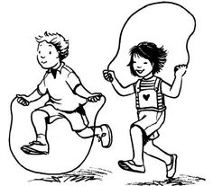 | - Developing the fundamental skills (Agility, Balance, Coordination)  - Applying fundamental skills into a range of scenarios  - Improving throwing and catching technique  - Application of skills into Dodgeball and Benchball  - Developing confidence to attempt personal challenges  - Improving communication to be a good team player
Other  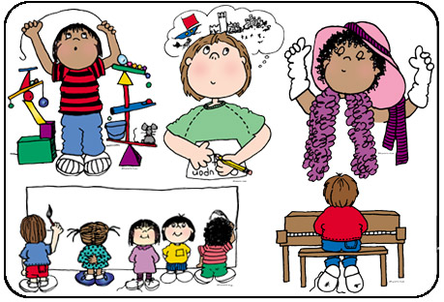 | - RE (Christianity) – What lights our way?  - Computing – Algorithms – Creating game apps using coding to help manoeuvre objects.  - PSHE – Respect, my identify, the people and services of our community  - Music – Gospel singing

