SHARE IN OUR LEARNING: Year 3 Autumn 2
English | Writing  - Discussing writing similar to that which they are planning to write in order to understand and learn from its structure, vocabulary and grammar  - In non-narrative material, using simple organisational devices (headings & subheadings)  - Our writing focus is to vary our sentences using fronted adverbials and conjunctions  - Use apostrophes correctly for both possession and contractions  - Begin to use inverted commas  - Explore homophones and meanings  - Use the first 2 or 3 letters of a word to check its spelling in a dictionary  Reading  - Draw inferences such as inferring characters' feelings, thoughts and motives from their actions  - Apply knowledge of root words, prefixes and suffixes to read aloud and to understand the meaning of unfamiliar words  - Experience and discuss a range of fiction, poetry, plays, non-fiction and reference books or textbooks  - Prepare poems to read aloud and to perform, showing understanding through intonation, tone, volume and action
Mathematics  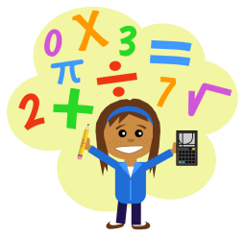 | Number and Place Value  - count from 0 in multiples of 4, 8, 50 and 100; find 10 or 100 more or less than a given number  Operations  - add and subtract numbers mentally, including: a three-digit number and 1s, a three-digit number and 10s, a three-digit number and 100s  - add and subtract numbers with up to 3 digits, using formal written methods of columnar addition and subtraction  - recall and use multiplication and division facts for the 3, 4 and 8 multiplication tables  - solve problems, including missing number problems, involving multiplication and division  Fractions  - count up and down in tenths; recognise that tenths arise from dividing an object into 10 equal parts and in dividing one-digit numbers or quantities by 10  - recognise, find and write fractions of a discrete set of objects: unit fractions and non-unit fractions with small denominators  - recognise and use fractions as numbers: unit fractions and non-unit fractions with small denominators  Measure  - add and subtract amounts of money to give change, using both £ and p in practical contexts  - tell and write the time from an analogue clock, including using Roman numerals from I to XII, and 12-hour and 24-hour clocks
Science  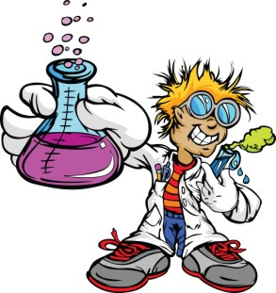 | Rocks  - compare and group together different kinds of rocks on the basis of their appearance and simple physical properties  - describe in simple terms how fossils are formed when things that have lived are trapped within rock  - recognise that soils are made from rocks and organic matter.
Topic | A Street through Time (Geography focus)  - name & locate geographical regions & their identifying human and physical characteristics,  - key topographical features (hills & mountains)  - Understand how land-use patterns changed over time- link to earliest settlements  - Physical geography: rivers, mountains – link to rocks/ earliest settlements  - use 8 points of a compass, 4-fig. grid references, symbols and key (including the use of Ordnance Survey maps) to build their knowledge of the UK
PE  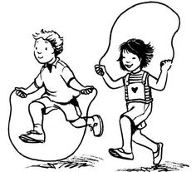 | Personal skills  - Social skills  - Show patience and support towards others  - Help, praise and encourage others  - Show and tell others about my work and listen to others ideas and opinions  - Help organise roles and responsibilities  - Guide a small group in a task  Fundamental skills  - Static balances  - Dynamic balance to agility  Sport  - Dance
Other  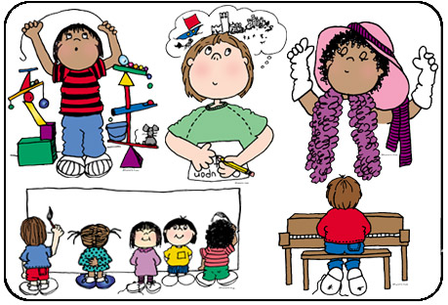 | Music  - The children will be working towards their keyboard performance in December  - Developing their finger placement and reading music  PHSE: Respect  - recognise their worth as individuals, by identifying positive things about themselves and their achievements, seeing their mistakes, making amends and setting personal goals  - understand why and how rules and laws are made and enforced, why different rules are needed in different situations and how to take part in making and changing rules  - reflect on spiritual, moral, social and cultural issues, using imagination to understand other people’s experiences  - understand that their actions affect themselves and others, to care about other people’s feelings and to try to see things from their points of view  - realise the nature and consequences of racism, teasing, bullying and aggressive behaviours, and how to respond to them and ask for help

