

Schools must use the funding to make additional and sustainable improvements to the quality of PE and sport they offer. This means that you should use the Primary PE and Sport Premium to:

- developoraddtothePEandsportactivitiesthatyourschoolalready offers
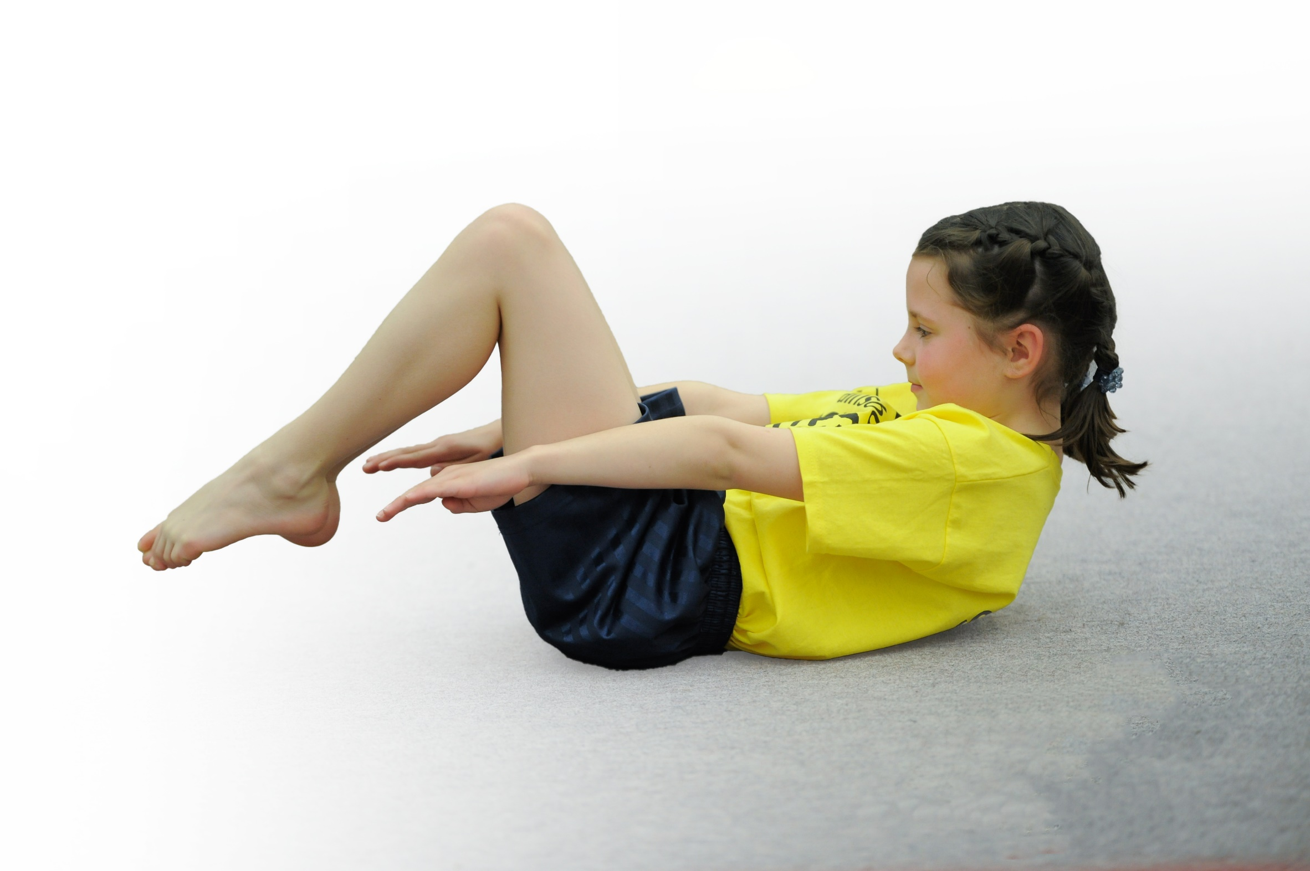
- buildcapacityandcapabilitywithintheschooltoensurethatimprovementsmadenowwillbenefitpupilsjoiningtheschoolinfuture years

Please visit gov.ukfor the revised DfE guidance including the 5 key indicators across which schools should demonstrate an improvement. This document will help you to review your provision and to report your spend. DfE encourages schools to use this template as an effective way of meeting the reporting requirements of the Primary PE and Sport Premium.

We recommend you start by reflecting on the impact of current provision and reviewing the previous spend.
Under the Ofsted Schools Inspection Framework, inspectors will assess how effectively leaders use
the Primary PE and Sport Premium and measure its impact on outcomes for pupils, and how effectively governorshold them to account
for this.

Schools are required to publish detailsof how they spend this funding as well as on the impact it has on pupils’ PE
and sport participation and attainment.
We recommend regularly updating the table and
publishing it on your website as evidence
of your ongoing review into how you are using the money
to secure maximum, sustainable impact. To see an example of how to complete the table please click HERE.

Support for review and reflection - considering the 5 key indicators from DfE, what development needs are a priority for your setting and your students now and why? Use the space below to reflect on previous spend, identify current need and priorities for the future.

Key achievements to date: | Areas for further improvement and baseline evidence of need:
Autumn Term  Real PE rolled out and showing to be successful in increasing staff confidence and pupil progress.  Competitive sports already begun are on target to achieve 80% of children representing the school this academic year.  Numbers of children being active at lunch times is on the rise.  Spring Term  Increased number of extra-curricular clubs including football, Change 4 Life, rugby, yoga and tennis.  Healthy Lifestyles Week organised with events such as Metafit, yoga, tai chi, running competition and sponsored row.  Opportunities for competition developed with Y2 children participating in a football tournament, and the entirety of Y3 and Y4 participating in a Tag Rugby tournament. 4 chn from Y6 participated in a G&T sports camp during the February half term  Fruit scheme trialed in Y3 and Y4. Showed to be a popular addition. Chn keen to swap their snacks with a piece of fruit, taking their less-healthy snack home.  Use of new equipment has continued to engage chn in lunchtime activities | Autumn Term  Children starting to bring less-healthy snacks to school again.  Increase opportunities for KS1 learners to be involved in after school sports clubs.  Spring Term  Roll out the healthy snacks (fruit programme) to the remainder of KS2 to ensure that all children throughout the school have access to a healthy snack.  Finalise arrangements for 4 chn in Y6 who are yet to complete their Swimming Proficiency.  Organise intra-school events for the Summer term. Include Y6 chn to help develop sports-leaders.

Meeting national curriculum requirements for swimming and water safety | Please complete all of the below:
What percentage of your Year 6 pupils could swim competently, confidently and proficiently over a distance of at least 25 metres when they left your primary school at the end of last academic year? | 87%
What percentage of your Year 6 pupils could use a range of strokes effectively [for example, front crawl, backstroke and breaststroke] when they left your primary school at the end of last academic year? | 87%
What percentage of your Year 6 pupils could perform safe self-rescue in different water-based situations when they left your primary school at the end of last academic year? | 100%
Schools can choose to use the Primary PE and Sport Premium to provide additional provision for swimming but this must be for activity over and above the national curriculum requirements. Have you used it in this way? | Yes/No

Action Plan and Budget Tracking
Capture your intended annual spend against the 5 key indicators. Clarify the success criteria and evidence of impact that you intend to measure to evaluate for students today and for the future.

Academic Year: 2017/18 | Total fund allocated: £17807 £17000 - £807 remaining | Date Updated: April 2018
Key indicator 1: The engagement of all pupils in regular physical activity – Chief Medical Officer guidelines recommend that primary school children undertake at least 30 minutes of physical activity a day in school |  |  |  | Percentage of total allocation:
 |  |  |  | £3300 19 %
School focus with clarity on intended impact on pupils: | Actions to achieve: | Funding allocated: | Evidence and impact: | Sustainability and suggested next steps:
Introduction of Road to Rio to get all children participating in physical exercise for at least 15 minutes during the school day. To commence from start of 2018. (New Year – New Me)  Sports and games equipment purchased for lunchtime club with MDA’s  Increase consumption of healthy foods.  Promote healthy eating through children/parent workshops. | Track to be set out with measurements to allow for chn to compete in Road to Rio competition.  Assembly time to explain the idea to children.  Staff to be informed at staff meeting.  Healthy Lifestyles Champions to also run the club at lunchtime.  Equipment such as skipping ropes, balls, bats, chalks to be purchased. Work with MDA’s to develop a register system to record chn who are/aren’t participating.  Provide opportunities for chn in ks2 classes to eat fruit/veg at play times to come in line with ks1 snacks and to also promote healthy eating. | £300  £1500  £1500 | The event has been scheduled to run in the Healthy Lifestyles Week (W/C 16/04/18) LS to get support from Y6 chn and midday’s to help tally distances ran by chn. Trophies will be awarded to chn who run the furthest distance over the course of the week.  New and hired equipment from WaSSP is being used regularly at lunchtimes. Children have enjoyed the opportunity to use archery sets, skipping ropes and fencing equipment so far this academic year  MDA’s report a large increase in physical activity at lunchtimes due to enthusiasm for equipment.  Idea has been trialed in Y4 and other classes have shown interest. Scheme to begin from Summer 1 term.  Contacted ‘Apple of my Eye’ with a view to delivering workshops for children and parents. Dialogue between parties ongoing. | Continue to provide new and engaging sporting opportunities. Generate register system to gather data on numbers of chn.  Chn have had the opportunity to use curling, fencing and archery equipment. Rowing machines will be brought in for Healthy Lifestyles Week.  Rolled out to the rest of KS2  Look at ways to use the school allotment to help provide our own fresh produce.  To implement the skills acquired to help sustain interest in healthy eating for both parents and children.
Key indicator 2: The profile of PE and sport being raised across the school as a tool for whole school improvement |  |  |  | Percentage of total allocation:
 |  |  |  | £3680 21%
School focus with clarity on intended impact on pupils: | Actions to achieve: | Funding allocated: | Evidence and impact: | Sustainability and suggested next steps:
LS to promote and develop PE, sport, wellbeing and healthy lifestyles throughout the school community in TLR role.  Celebrate chn’s sporting successes with a weekly sports person award in celebration assembly. To commence from start of 2018.  PE display board to be placed in the outdoor classroom as well as Road to Rio display board.  Deployment of Healthy Lifestyle Champions in school who will work with PE lead to help promote participation within the school  Healthy Lifestyles Theme week is planned to raise the profile of sports, PE and wellbeing. | To lead on all aspects of the PE curriculum as shown within this document.  To be accountable for the spending of the PE and sport Premium.  Create a certificate for each class.  Ensure system focuses on those chn who are least active to encourage them to want to increase participation.  Make parents and children aware of the board and continue to change to show sporting achievements in the school.  Champions to attend training days with PE lead to develop their skills and confidence. | £2630  £50  £1000 | Reviewed that there are already a vast amount of certificates being given out in Friday assemblies. Decided that to provide worth and value, that we will focus our attentions on awards through Healthy Lifestyles Week, then re-evaluate how we can continue to push with encouraging active lifestyles.  PC, RR, IB are running the Active Lifestyles club themselves with LS overseeing and providing feedback to the girls for future sessions.  Champions have been trained by LS to set up and run the C4L club under his supervision. Their enthusiasm for generating new ideas and involving all chn (particularly the younger learners) has been a huge success. | LS to promote to the chn and create certificates.  Medals and trophies to be purchased  Continue to train leaders so that they are confident at running lunchtime club too to increase participation opportunities.  Book professionals to come to school and lead on areas in physical education and mental wellbeing.  Confirmed sessions: Tai Chi, Yoga, MetaFit

Key indicator 3: Increased confidence, knowledge and skills of all staff in teaching PE and sport |  |  |  |  | Percentage of total allocation:
 |  |  |  |  | £3550 20%
School focus with clarity on intended  impact on pupils: |  | Actions to achieve: | Funding  allocated: | Evidence and impact: | Sustainability and suggested  next steps:
Bought into Real PE scheme of work to help promote high quality teaching and learning in PE.  Staff will have a clearer understanding of the delivery of PE, how to promote inclusion and challenge.  Dance and Gymnastics CPD |  | INSET day led by Real PE representative to guide us through the programme.  LS to attend regular training days to develop use of assessment package and to develop the quality of PE lessons.  LS to support staff in improving the delivery of PE lessons. Complete staff confidence questionnaire at start of academic year.  Learning walks to identify how Real PE is being utilized and delivered across the school.  Continue to develop the expertise of teaching PE. Learning walk in Autumn term for base lining and then ongoing throughout the year. Provide training for staff to develop teaching. Look for specific CPD for any areas of development. Repeat learning walk in Summer term to see impact of training.  Ensuring coverage of all areas of PE. Teachers to provide a yearly guide of the PE curriculum they are teaching with an expectation of 2 hours per week. Overview of coverage and sports this is being covered linked closely to the National Curriculum guidance and Programmes of Study.  Staff voice suggests that of all areas, these are the areas in which they require additional CPD support. | £1550  £1000  1000 | Staff and chn show enthusiasm for the new scheme of work. Chn are enjoying the inclusion of competition, personal bests and being challenged. Staff find the scheme easy to use and are adapting ideas to suit the needs of their class.  Pupil conferencing shows confidence in the new scheme with chn feeling that they participate in lessons much more now. | Monitor through learning walks, pupil conferencing  CPD to continue throughout the year and LS to lead on staff meetings.  LS to organize for CPD later in the academic year through Real Dance.
Key indicator 4: Broader experience of a range of sports and activities offered to all pupils |  |  |  |  | Percentage of total allocation:
 |  |  |  |  | £3750 21%
School focus with clarity on intended  impact on pupils: | Actions to achieve: |  | Funding  allocated: | Evidence and impact: | Sustainability and suggested  next steps:
To increase participation in extracurricular sports to at least 50%  Provide a range of after school sports clubs  Set up and run the Change 4 Life club  Improve mental wellbeing of chn. | To work with the MDA’s to set up a lunchtime sports club.  Utilise the skills of school staff as well as bringing in professional coaches to give a broader range of activities.  Warrington Disability Partnership club  Target the club at the least active chn within the school.  Promote active lifestyles throughout the school.  Provide a range of activities which may be unfamiliar to some chn.  Warrington Wolves coaching for all of KS2 inc. after school club.  Create opportunities for chn to improve their mental wellbeing through yoga and meditation sessions. |  | £2000  £300  £450  £1000 | As above, numbers participating in lunchtime activities has increased considerably due to the draw of the new equipment. LS to generate a register based system to gather data on these numbers more accurately.  Warrington Disability Partnership club ran successfully throughout the term. Chn participated in a range of activities such as boccia, blindfold football and sit down volleyball.  C4L successfully continuing with high demand for the club.  Tennis and Warrington Wolves clubs are currently in process.  Yoga club continues to run every Thursday and staff have talked positively about the impact on children who settle well into lessons after a calm start to the day.  Taster sessions completed. Feedback from DC was very positive. | Waiting list in place and chn on the list will be given the opportunity to participate in the Spring term.  Enquiries made for tennis and/or boxercise after school clubs to run from January.  Warrington Wolves to run an afterschool rugby club from Spring 2.  Explore opportunity of yoga/meditation sessions to begin before school. Targeted initially at PP chn and those who require additional support in behavioural coping strategies.
Key indicator 5: Increased participation in competitive sport |  |  |  |  | Percentage of total allocation:
 |  |  |  |  | £2720 15%
School focus with clarity on intended  impact on pupils: |  | Actions to achieve: | Funding  allocated: | Evidence and impact: | Sustainability and suggested  next steps:
To increase involvement in competitive sporting events so that at least 80% of children have represented the school.  Increase % of children leaving school being proficient at swimming (to curriculum expectation) |  | Develop competition across the school and within the school  J Join Warrington Schools Football League to ensure increased participation.  Become members of the Warrington Schools Sports Partnership, giving us access to a large range of competitive sporting events throughout the year. Ensure all chn have the opportunity to participate, especially the least active in the school.  Participation in the annual Warrington Wolves Tag Rugby Festival for Year 3/4  Identify from historical data the chn in year 6 who require additional support in achieving ARE in swimming proficiency.  Explore opportunities for further swimming lessons for this target group. | £500  £20  £1700  £500 | School football team have joined the Warrington Schools Football League and have so far competed in 2 competitive games.  Further fixtures will commence in the new year with 6 other games to play.  LS has organised events through the WaSSP which are booked into the calendar for next year, ensuring that each year group is given opportunities to participate and represent the school.  By the end of Spring 2 at least 60% of chn will have represented the school in a sporting event this academic year.  Y2 participated in a school football tournament and finished in 3rd place.  All of Y3 and Y4 participating in a Rugby tournament w/c: 26/03/18  List if chn not meeting the expectation has been collated and LS has contacted Livewire about the availability to take these chn from Y5 and 6 to additional lessons in the next calendar year. Awaiting response at present.  Opportunities were available but through SATS week. It was felt that leaving it until after SATS would be better and therefore, now looking at dates for the summer term. | Maintain the level of competition and look for opportunities for individual sports too such as cross country events.  4 children from Y6 went to a Priestley College Gifted and Talented event at Priestley College during the February half term.  Entirety of Y3 to participate in cricket tournament in May  Y6 to particpate in June  Y5/6 rugby tournament at Halliwell Jones in April.  All of Y5/6 to participate in a rugby tournament later in the school year.

